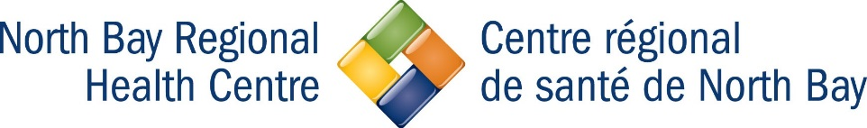
For use only by Researchers
Request for Ethics Approval of Amendment to an Approved Protocol

Please complete and submit one (1) typed, signed original, and/or one (1) electronic version, including signatures of this form to:

Ashley Foreman
Research Ethics Board Administrator
North Bay Regional Health Centre
50 College Drive, North Bay, ON P1B 5A4
Tel: 705-474-8600 ext. 2518
(REBOffice@nbrhc.on.ca)
Instructions:

- Handwritten forms are not accepted.
- An amendment to an approved project can be requested when change(s) must be made in order to complete the work that was described by the approved ethics submission.
- Amendments can be submitted at any time.
- This form must be completed and submitted with a copy of the amended protocol indicating the relevant sections for proposed changes.
- The amendment documentation will be reviewed. The amendment may be approved as submitted, or revisions may be requested that must completed and resubmitted prior to approval.
- Amendments may not be implemented until such time as the researcher receives notification of approval. This will initially be done by email, with a supplement letter sent for signature to the investigators mailing address.

SECTION A: GENERAL INFORMATION

Principal Investigator Protocol File Number

Protocol Title

Address

Telephone Number Email Address

SECTION B: CHANGES REQUESTED

- Check the modifications you wish to make to the research project:

Research Design or Methodology Study End Date
Participant Sample/Population Data Confidentiality
Research Instruments Changes to Research Team
Participant Recruitment Process Status and Funding
Consent forms/Information Sheets Other
- Does this amendment represent a substantive change to the approved protocol? Explain:
*Note: If changes are substantial a full committee review is required.

The Research Ethics Board will review your request for an amendment. Any other documents that may be changed as a result of your amendment should be appended to this form.

For Administrative Use Only:

The amendment request for this project has been reviewed and approved.

Expedited Review Full Board Review

Signature of Research Ethics Board Chair or Designate: Date:

Approval period from: to:

I certify that the information provided in this Request Ethics Approval for Amendment to an Approved Protocol form is complete and accurate. I have complied with the Tri-Council Policy Statement and North Bay Regional Health Centre’s policies and procedures governing the protection of human participants in research.

Signature of Principal Investigator:
Print Name:
Date:

